***Project synopsis report on***

**“QUESTION BANK MANAGEMENT SYSTEM”**

*Submitted by*

Zinia Ahmed, 202116051, BCA 6th Sem, Dept. of CA, zinia_202116051@smit.smu.edu.in.

Anjula Gupta, 202116026, BCA 6th Sem, Dept. of CA, anjula_202116026@smit.smu.edu.in.

Hibung Tasso, 2021160, BCA 6th Sem, Dept. of CA, hibung_202116011@smit.smu.edu.in.

Nischal Nikhil, 202116021, BCA 6th Sem, Dept. of CA, nischal_202116021@smit.smu.edu.in.

*Under the Supervision of*

Mr. Bishal Pradhan, Assistant Professor, Dept. of CA, SMIT

Name & Signature of Members Signature of Guide

***Zinia Ahmed:***

***Anjula Gupta:***

***Hibung Tasso:***

***Nischal Nikhil***

**Abstract**

The project "Question Bank Management System" aims to develop a user-friendly platform for efficiently managing and organizing a repository of questions. This system allows users, such as educators or teachers, to create, store, categorize, and retrieve questions based on various criteria like subject, topic, difficulty level, and more. Additionally, it facilitates easy creating, editing, and assessment of questions, streamlining the process of generating question paper for quizzes, and exams. Through intuitive interfaces and robust database management, this system enhances productivity, collaboration, and the overall quality of educational content development.

***Keywords*:** *Question Bank, Database, Repository, Question types, Question Paper*

1. **Introduction**

The Question Bank Management System is a web-based application designed to streamline the organization, creation, storage, retrieval and generating educational question paper. It serves as a centralized repository where teachers and administrators can manage a wide variety of questions across different subjects and topics. The system allows users to categorize questions based on various criteria such as subject, topic, and difficulty level, making it easy to search and retrieve specific questions when needed. Teachers can also create, edit, and share questions. Additionally, the system may include features for generating quizzes, and exams using the stored questions. Overall, the “Question Bank Management System” enhances efficiency in educational question development.

1. **Aims and Objectives**

**Aims:**

1. Provide collections of questions for teachers.

2. Question Paper Generator (quiz, sessional, end-semester exam)

**Objectives:**

1. Create an intuitive and user-friendly interface that enables educators to easily navigate the system, create new questions, and modify existing ones without extensive training.
2. Develop a system that allows teachers to efficiently create, store, organize, and manage a large number of questions for various subjects and topics.
3. Establish a centralized repository for storing questions, ensuring easy access and retrieval by educators whenever needed.
4. Support a variety of question types, including multiple-choice, true/false, short answer, and more to cater to diverse assessment needs.
5. **General overview of the problem**

Manually preparing question papers is a time-consuming task that requires teachers to spend significant hours brainstorming, writing, and formatting questions.

1. **Feasibility Study**

**Technical Feasibility:**

The required hardware, software, and technological infrastructure of the system are feasible from a technical perspective we are going to use HTML, JavaScript, CSS for frontend designing and MySQL & asp.NET (.NET FRAMEWORK) for databases to create a robust and user-friendly system

**Operational Feasibility:**

The project we are developing as there is no need for users to have good knowledge in computer before using it. The user can learn and use the system by their own.

**Economic Feasibility:**

The tools we will be using to develop the system are not expensive and the software’s are open source. Even the maintenance of the system will not be expensive. The system is indeed economically feasible.

1. **Problem Definition**
2. **Time consuming:** Traditionally, manually preparing question paper takes more time.
3. **Difficulty in preparing Question Paper**: It is difficult to collect and prepare questions from different sources.
4. **Risk of Question Duplication:** Question duplication occurs when a teacher prepares a question without knowledge of whether it has been used in previous years, resulting in the repetition of questions.
5. **Proposed Solution Strategy**
6. Online question bank management systems provide intuitive interfaces for educators to create, edit, and organize questions efficiently. Questions can be categorized by subject, topic, difficulty level, and other relevant criteria, making it easier to manage and retrieve them when needed.
7. These systems enable educators to build and maintain a comprehensive question pool by adding new questions regularly. This ensures a diverse range of assessment materials and reduces the likelihood of question repetition across different exams.
8. Online systems automate repetitive tasks involved in question paper creation, such as question selection, formatting, and arrangement. This saves educators valuable time and allows them to focus on other aspects of teaching and learning.

1. **Literature Survey or Survey**

|  |  |  |  |
| --- | --- | --- | --- |
| **Author name/ Journal name/ Title of the paper** | **Work Done** | **Methods and Materials** | **Research Gap** |
| El-Sofany, H. F., Al-Jaidah, N., Ibrahim, S., & Al-kubaisi, S. (2009). | 1. Exams generation: Teachers can store many types of questions like multiple choices, true/false and fill in the blanks. The system uses an intelligent algorithm to generate balanced exam sheet, that containing different types of questions, covering the entire curriculum and displaying gradually from easiness to difficulty. | The administrator application: This application provides the school administrator with simple tools to manage the information of the Questions-Bank system.  The following are some features provided by the administrator application:  • Activate/Inactivate the system  • Import and Export the questions-bank database  • Send automatic email immediately containing the new password whenever the user changes his/her password  • Administer the basic information of the system such as: Levels data, subjects or courses data, classes' data, teacher's data and students' data | 1. No Question Paper Generator |
| 1. Communication: The system has a communication tool that allows students and teachers to interact together and discuss their activities. | The teacher application: This application provides the teachers with various tools to construct the system services. The following are some features provided by the teacher application:  • Change account password  • Manage (add, update, delete and display) all the system services (reviews, exam questions, quizzes, previous exams and model answers) |
| 1. Course management: The system is highly flexible and doesn’t necessitate any programming skills from its potential users. Thus, teachers can add, delete and update their course materials at any moment through the web. | The student application: This application provides the students with interactive tools to use the services of the system. The following are some features provided by the student application:  • Change account password  • Download assignments, revision documents, previous exams and other files that are uploaded by the teachers  • Take web-based quizzes, exams, assignments, interactive tutorials and reviews |

1. **Project Plan**
   1. **Team Structure:**

Mr. Bishal Pradhan

(Guide)

Mr. Nischal Nikhil

(Member)

Miss. Anjula Gupta

(Member)

Mr. Hibung Tasso

(Member)

Miss. Zinia Ahmed

(Member)

* 1. **SDLC (*in case of Application Development*)**

Waterfall model for developing a “Question Bank Management System”:

Requirement Gathering

System Design

Implementation

Testing

Deployment

Maintenance

1.**Requirements Gathering:**

🡪 Gather requirements from stakeholders such as teachers, administrators, and students.

🡪 Define the features and functionalities of the system including question creation, categorization, storage, retrieval, and analysis.

2. **System Design:**

🡪 Define the database schema for storing questions, metadata, and user information.

🡪 Design the user interface for different types of users such as administrators, teachers, and students.

3. **Implementation:**

🡪 Implement the database using a suitable database management system (e.g., MySQL).

🡪 Implement features for question creation, editing, categorization, and management.

4. **Testing:**

🡪 Perform unit testing to ensure individual components work as expected.

🡪 Conduct integration testing to verify that different modules integrate smoothly.

🡪 Perform system testing to validate the system against the requirements.

🡪Conduct user acceptance testing to ensure the system meets the needs of its intended users.

5. **Deployment:**

🡪Deploy the system on a suitable server infrastructure.

🡪Configure the system for production use, including setting up user accounts and permissions.

🡪Ensure proper backup and recovery mechanisms are in place.

6. **Maintenance:**

🡪Provide ongoing support and maintenance for the system.

🡪Address any issues or bugs reported by users.

🡪Perform updates and enhancements based on user feedback and changing requirements.

* 1. **Gantt Chart (Project Schedule)**

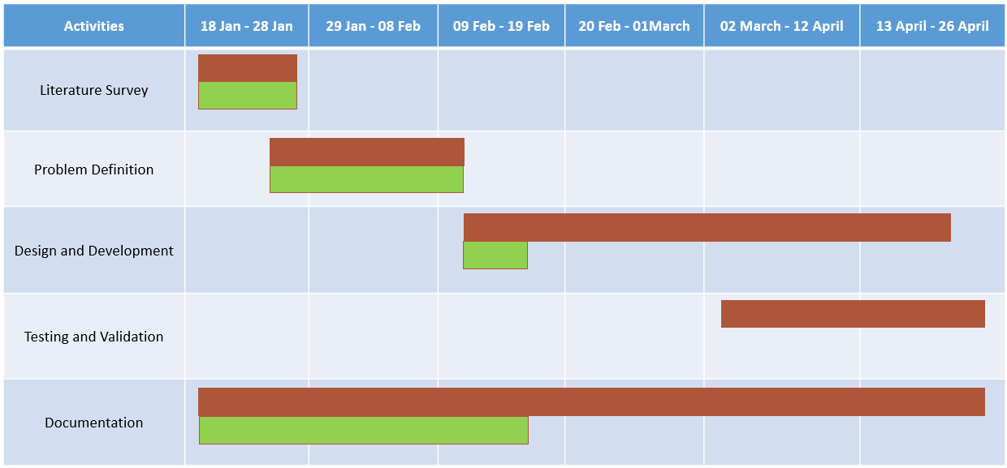

* 1. **Hardware and Software Requirement Specifications:**

**System information**

* **OS:** Microsoft Windows 11 Home Single Language
* **Processor:** 11th Gen Intel(R) Core i5-11400H @ 2.70GHz (6 Cores, 12 Logical Processors)
* **RAM:** 16.0 GB
* **BIOS:** American Megatrends International, LLC. FX506HEB.313 (03-03-2023)
* **System Type:** x64-based PC
* **BIOS Mode:** UEFI

1. **Conclusion**

The "Question Bank Management System" project aims to create a user-friendly platform for teachers to efficiently manage and organize educational questions. It simplifies the process of creating question papers for quizzes and exams, enhances productivity, collaboration, and the quality of educational content development.